Array

4 | 3 | 1 | 6 | 8 | 10 | 12

- Array can store data of specified type
- Elements of an array are located in a contiguous
- Each element of an array has a unique index (array index start from 0 by default)
- The size of an array is predefined and cannot be modified
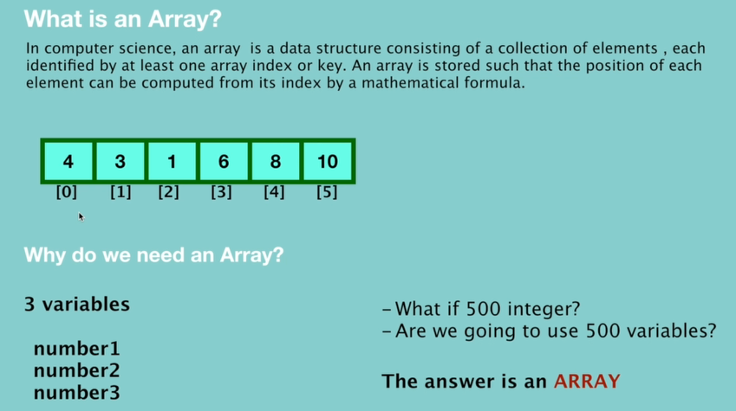
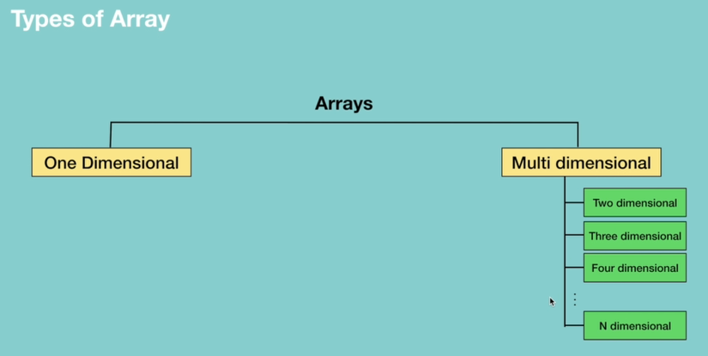
- 1 -dimensional array - array[row-index]
- 2 – dimensional array – array[row-index] [column-index]
- 3 – dimensional array – array[depth][row][column]
